Intercoms for emergency communication

Description:
Paging from 2N IP Intercom is a feature that can be used for any announcement that will be sent to all other intercoms (or to a specific group of intercoms). These devices have to be set to receive a multicast stream on the predefined multicast IP address and port. Afterwards, press a button on 2N® IP Intercom and start talking to all other intercoms, play announcements or play any emergency message (e.g. for the evacuation of the building).

Sending Intercom Automation

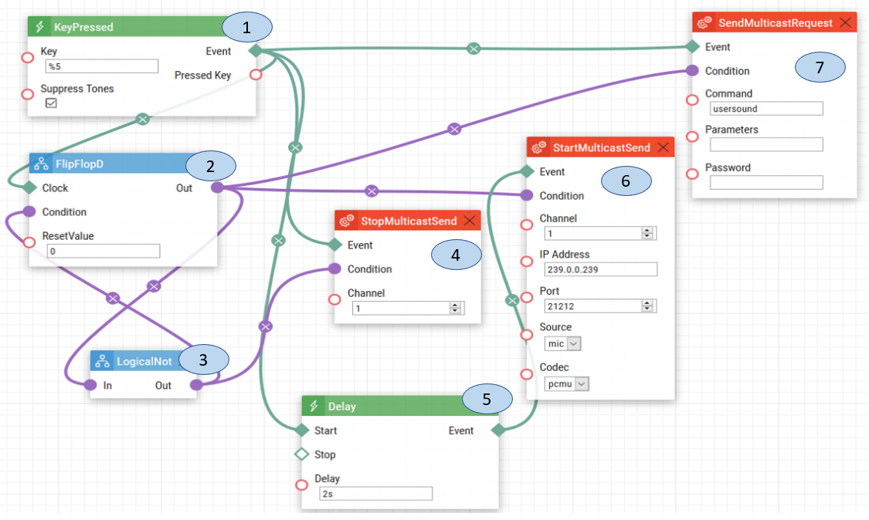

- Key Pressed. When the number five is pressed on the keypad, a signal is sent to the Flip Flop D, Delay, Send Multi Cast Request and Stop Multicast Request.
- Flip Flop D. When the signal is received from the Key pressed, it will send that signal to Logical Not, to receive the reversed version of the signal. Once the Flip Flop D has received the reversed signal it will send out the new signal to Start Multicast Send and Send Multicast Request to make them able to send the communication from the intercom.
- Logical Not. This will change the value of the signal by reversing it from 1 to 0 or 0 to 1. The reverse signal value will be sent to Flip Flop D and Stop Multicast Send, which will allow for the broadcast from the intercom to stop once the number five on the keypad is pressed the second time.
- Stop Multicast Send. The Stop Multicast Send will close the multicast channel only if the number five is pressed for the second time.
- Delay. The signal from the Key Pressed is sent to the delay, to allow time for the multicast channels to open and be ready for broadcasting.
- Start Multicast Send. The Start Multicast Send will start the broadcast from the intercom over a specific channel and port.
- Send Multicast Request. The Send Multicast Request will send the signal to all the intercoms on the same channel and port to broadcast.

Receiving Intercom Automation

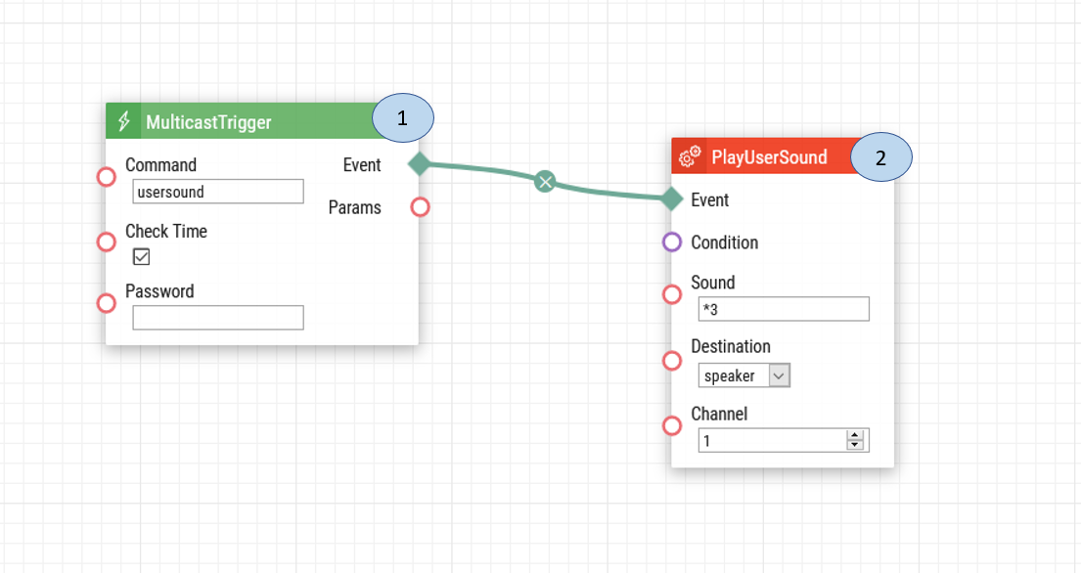
- Multicast Trigger. Once the multicast starts to receive a stream. It will send a signal for a user sound to be played.
- Play User Sound. The sound played when the door is opened without authorization.

Note: For this automation to work, there must be automation set up to send the announcement on the sending intercom and another automation on receiving intercom, so the emergency tone can be played. The receiving intercom must also have the Multicast Receiver Enabled. The IP address and port will be based on the multicast settings in your network.

Intercom Door Configuration:

To set up the Multicast Receiver:

1: Upon login select the Services option.
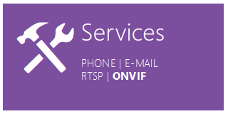

2: On the left-hand menu select Streaming.
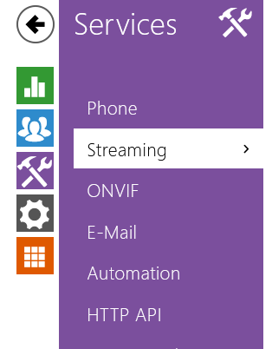
3: Select the Multicast tab.
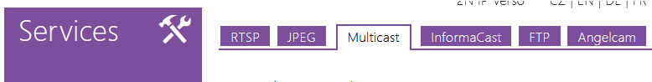
4: Select the Multicast Receiver Enabled and then input the multicast address, port and codec similar to the example below. After you have finished inputting the settings, click Save.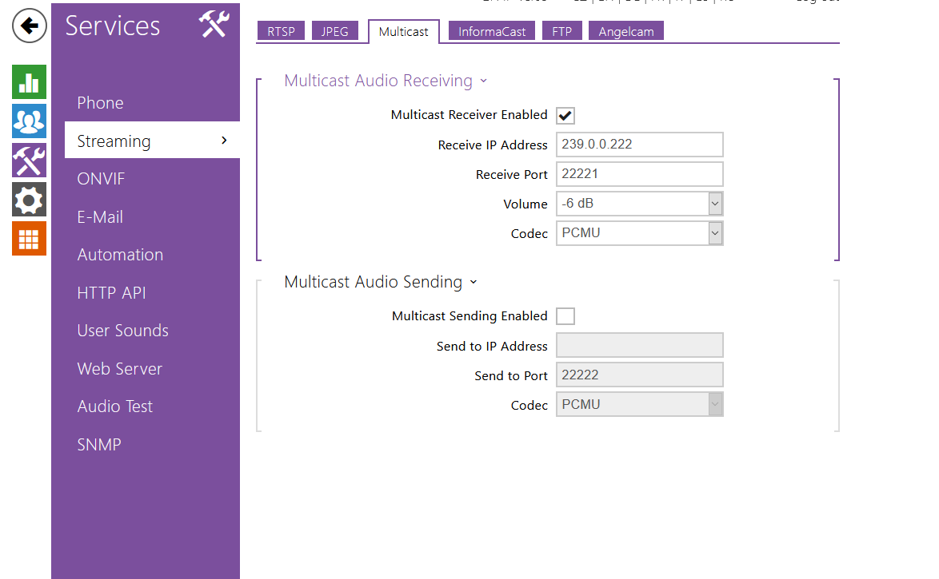

Note: Codecs must match on both sides

Date of automation design: 07/17/2020

Firmware Version: 2.29.1.38.8
List of compatible hardware:
- 2N IP Verso
- 2N IP Solo
- 2N IP Vario
- 2N IP Force
- 2N IP Safety
- 2N IP Base

List of adjustable user credentials:
- Users
- User code
- Entry code
List of automation parameters:
- Key
- Reset Value
- Channel
- Delay
- IP Address
- Port
- Source
- Codec
- Command
- Parameters
- Password
- Sound
- Destination

Requirements:
- 2N Intercom with automation
- 2N Enhanced Integration license (or Gold license) *Not applicable to the USA

