Picture to e-mail and motion detection

Description:
Sending a picture to email in case of detected movement in front of the intercom.

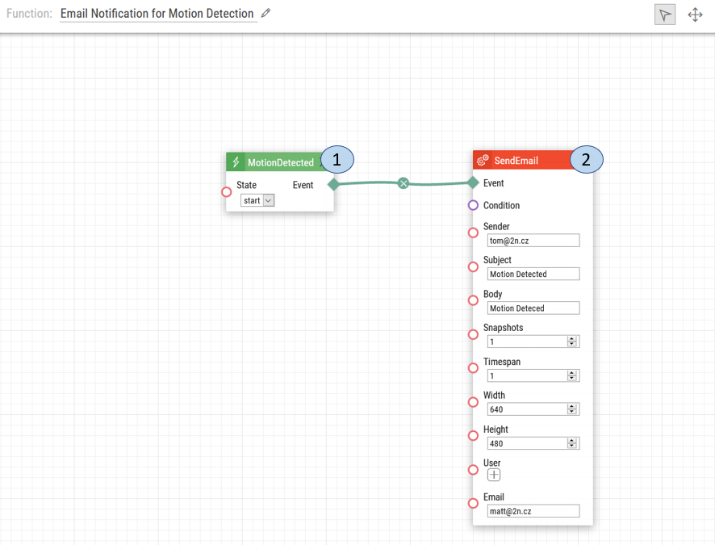
- Motion Detected. Once motion is detected, a signal is sent for the intercom to send an email to the stated recipient.
- Send Email. An email will be sent from a specified sender to a stated receiver containing snapshots from the camera.

Note: This automation will cause an email to be sent with a snapshot when the 2N IP Intercom detects motion. For the email notification to work, please ensure you set up the SMTP. The configuration can be set up using for example a Gmail account, with the steps found here.

Intercom Camera Configuration:
After the automation is complete, please follow the steps below to configure the intercom’s internal camera ability to detect motion.

1. Upon login select Hardware setting.
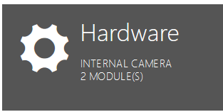

2. Choose the Camera option on the left-hand menu.
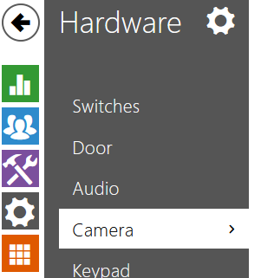

3. Choose the Internal Camera appropriate tab at the top.

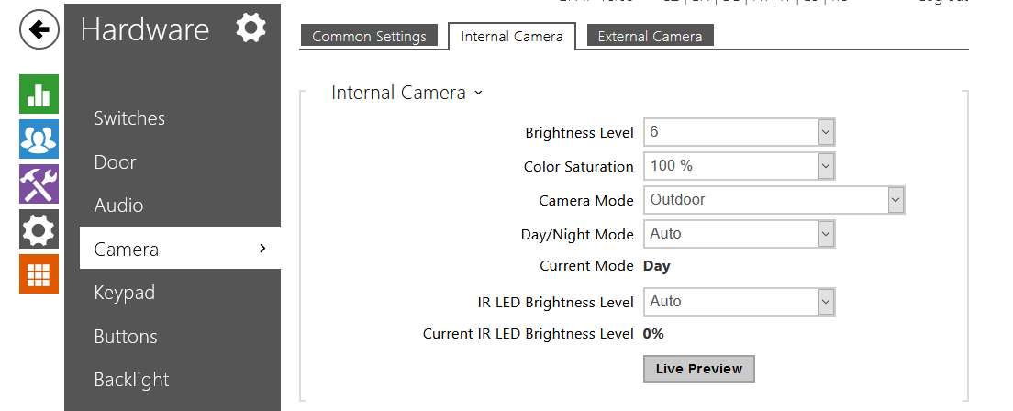

4. Enable the Motion Detection option and select the area of the picture where the motion shall be detected by the camera. Afterwards, click Save.
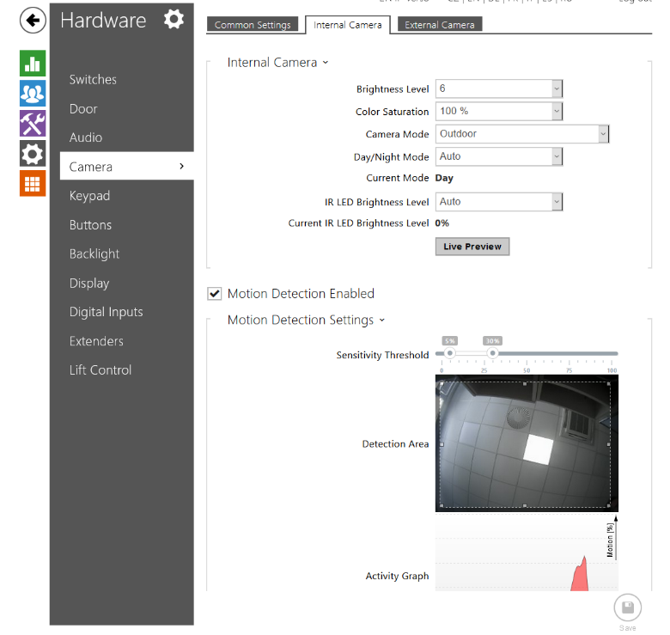

Date of automation design: 07/17/2020

Firmware Version: 2.29.1.38.8

List of compatible Hardware:
- 2N IP Verso
- 2N IP Solo
- 2N IP Vario
- 2N IP Base
- 2N IP Force
- 2N LTE Verso

List of adjustable user credentials:
- Users
List of automation parameters:
- State
Send Email Parameters:
- Senders
- Subject
- Body
- Snapshots
- Timespan
- Width
- Height
- User
- Email

Requirements:
- 2N Intercom with internal camera
- 2N Enhanced Integration license and 2N Enhanced Video license (or Gold license) *Not applicable to the USA

