Activation and deactivation of alarm using card

Description:

Make enabling/disabling 3rd party alarm quick and easy by simply holding your card for a moment, all of this with visual LED signalization:

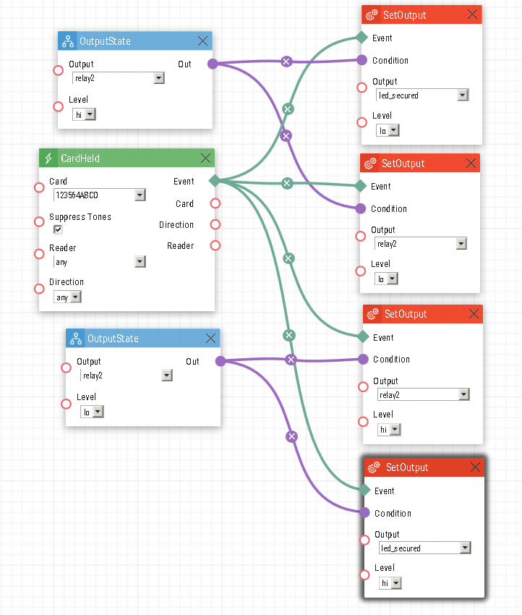
Note: This automation will cause the LED signalization to lock the door if a card is held for 5 seconds on the card reader, which is meant to represent a third-party alarm being tripped. To disable the alarm and disable the LED signalization.
Below is a simpler way to perform the automation, by a Logical Not and Flip Flop D block that will change the output from on to an off and vice versa.

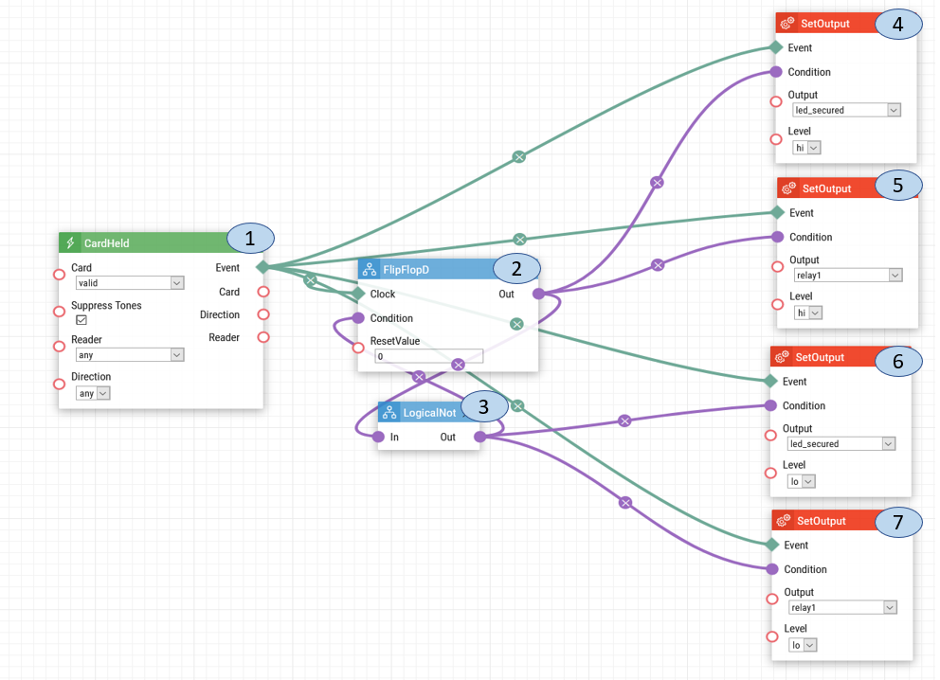

- Card Held. When a valid card is held to the RFID card reader, a signal is sent to Timer and Flip Flop D.
- Flip Flop D. When the signal is received from the Card Held, it will send that signal to Logical Not, to receive the reversed version of the signal. Once the Flip Flop D has receives the reversed signal it will send out the new signal to Activate Switch.
- Logical Not. The Logical Not will change the value of the signal by reversing it from 1 to 0 or 0 to 1. The reverse signal value will be sent to Flip Flop D.
- Send Output. The signal received from the Card Held and Flip Flop D will enable the led_secured which will send a signal to cause the door to permanently lock.
- Send Output. This will cause the relay to become permanently locked.
- Send Output. The signal received will cause the led_secured to stop the permanently lock signal.
- Send Output. This will cause the relay to return to the previous operational state.

User Card Configuration:
To ensure that the automation works, a valid card must be entered into a user's profile. Please follow the steps below to enter a card ID.

1: To find a card's ID, swipe the card over the reader, then go to status choose events.
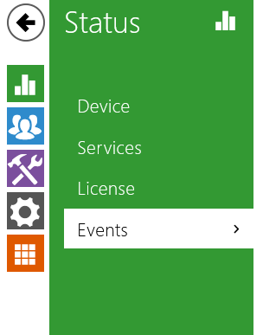

2: The card's ID will appear in the section of UID. Copy the card ID.

3: Choose the Directory option.

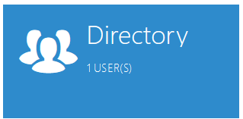

4: Select the user and under the section User Cards, enter the card IDs. And lastly, save the settings.
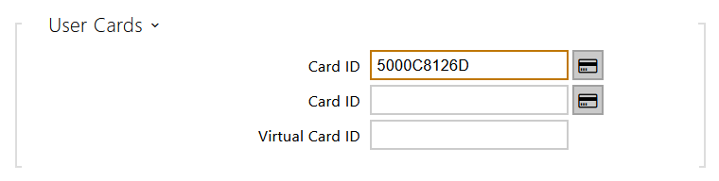

Date of automation design: 07/17/2020

Firmware Version: 2.29.1.38.8

List of compatible Hardware:
- 2N IP Verso with RFID
- 2N IP Vario with RFID
- 2N IP Base with RFID
- 2N IP Force with RFID
- 2N LTE Verso RFID
- 2N Access Unit 2.0 with RFID (Secured LED not available)
- 2N Access Unit with RFID

List of adjustable user credentials:
- Users
- Cards
- Fobs
List of automation parameters:
- Card
- Reader
- Direction
- Reset Value
- Output
- Level

Requirements:
- 2N Intercom with Card Reader
- 2N Enhanced Integration license (or Gold license) *Not applicable to the USA

